***PART A***

1. *Use semantic elements*Check.
2. *Sections with ID attributes to be used as targets*Check.
3. *Menu with a href elements that target Number 2 above*Check.
4. *Sections alternate between image background and a coloured background*Check.
5. *Content delivered one screen at a time with internally targeted hyperlinks*Pretty sure that’s a check.

***PART B***

1. *Generous use of CSS box model to ensure whitespace*Define generous/Check.
2. *Inline methodology: inline-block*Check.
3. *Layout should be in flow. No position: absolute*No position absolutes, check.
4. *Styling exclusively on semantic elements not id or class*Check.
5. *Demonstrated use a CSS combinator*Check. “**nav >a**”

***PART C***

1. *At least one (1) Image edited with a repeatable background*All images bar logos edited to other filetypes or compressed/cropped for readability.
2. *Contrasts in images low such that superimposed text is legible (WCAG 2.1 AA Standard)*All text legible, check.
3. *Example of an image background with another image superimposed on top*Check, see first section.

***PART D***

1. *Screenshot of W3C Validation of HTML & CSS  
   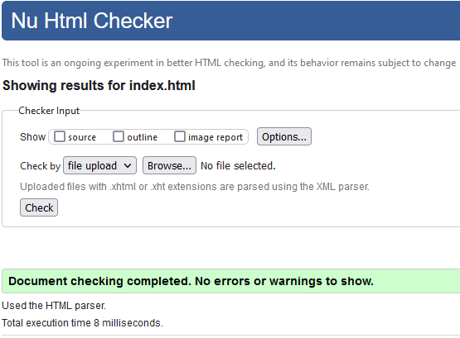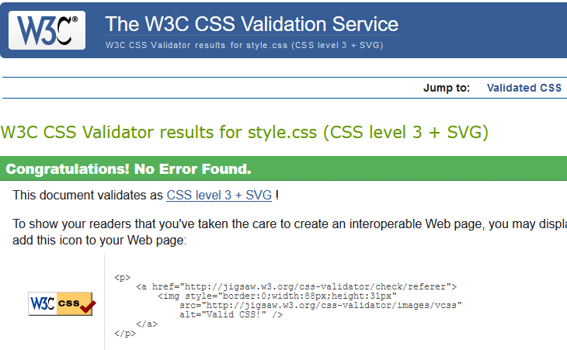*Check and check.
2. *Correct Indentation of HTML CSS and JavaScript*Fairly certain that’s a check.
3. *Cross-Browser test three examples  
   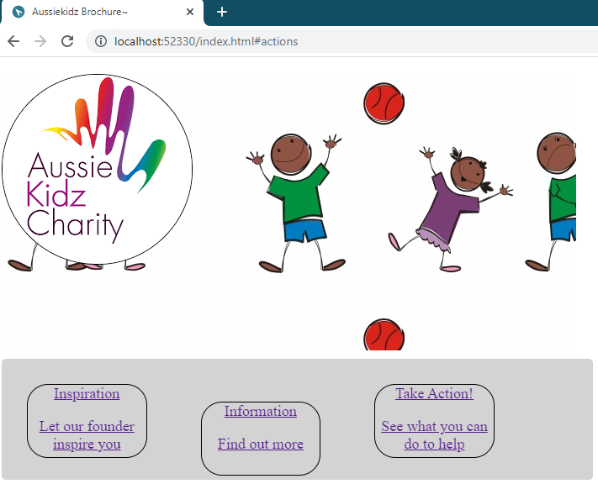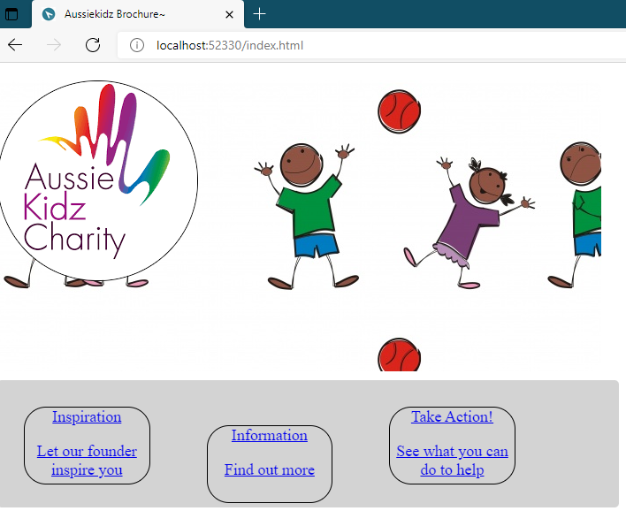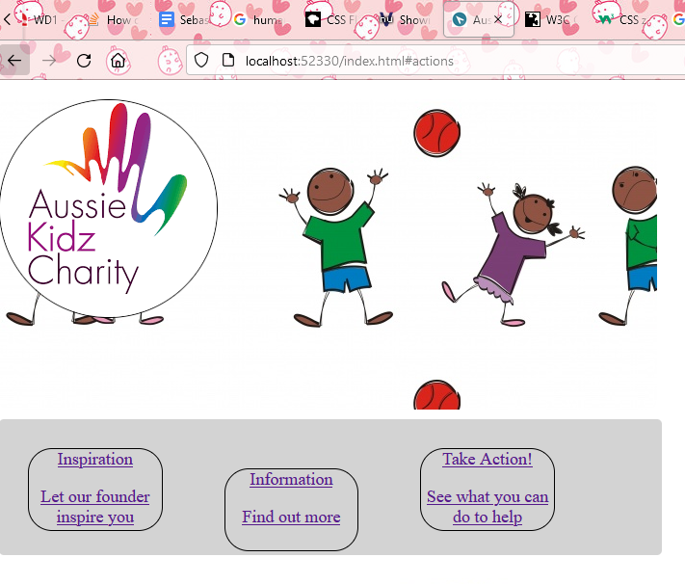*Check, **Chrome**. Check, **Edge**. Check, **Firefox**. In that order.
4. *All filenames are lowercase, no spaces and an index.html is in the root folder*Check.
5. *Image, CSS, JS folders contain relevant files each should not exceed 5mb*Total project folder size is less than 5 megabytes, check.

***PART E***

1. *Describe how the images chosen meet the client brief*The images in question best represent the tone of positivity in youth, even those bearing hardship, that the non-profit client would like users to associate with their charity work, thereby meeting the client brief.
2. *How have your modified images better suited the web medium*“humanchildjpg.jpg” was originally acquired as “humanchildpng.png”, then edited in MS Paint to a better compression ratio, reducing filesize and increasing load speed for users.
3. *What rationale was used when choosing the file format for each image*

PNG was used due to its ability to adapt to stylings and compression losslessly.   
JPEG was used due its smaller filesize allowing faster load speeds.

1. *Note Source for all images, including copyright and/or license requirement(s)*<https://i.pinimg.com/originals/63/9a/46/639a46c8b398b081cc0fd9f4e2c9c00f.png>, *“humanchildjpg.jpg” PurePNG©, Creative Commons License.*  
   <https://media-exp1.licdn.com/dms/image/C510BAQGrNIJxS8YTiw/company-logo_200_200/0/1551757854777?e=2159024400&v=beta&t=v7tcbxent8YEX12PASvtwnnJwrRFeZDzp5qc8lMjKb4>   
   *“aussiekids.png” LinkedIn/AussieKidz©, Creative Commons Licence*   
     
   <https://www.publicdomainpictures.net/pictures/250000/nahled/children-playing-1516284620Afc.jpg>  
   *“childrenplayingpng.png” Public Domain Pictures©, Creative Commons Licence  
     
   “rpvlogo.png” is a creation of my own design made in Blender and Aseprite.*
2. *Sell your design to client (Teacher). Describe how it meets client objectives*

This design is evocative of the plight of the children the foundation aims to assist. Its strong use of emotive language, imagery and playful colouring, alongside spirited calls to action encourages viewers/users to make a donation, thereby fulfilling the requirements of the website and the objectives of the client.

1. *Print final design to a single page PDF, edit into a poster (remove header/footer/pagination)* Check, see attached pdf.